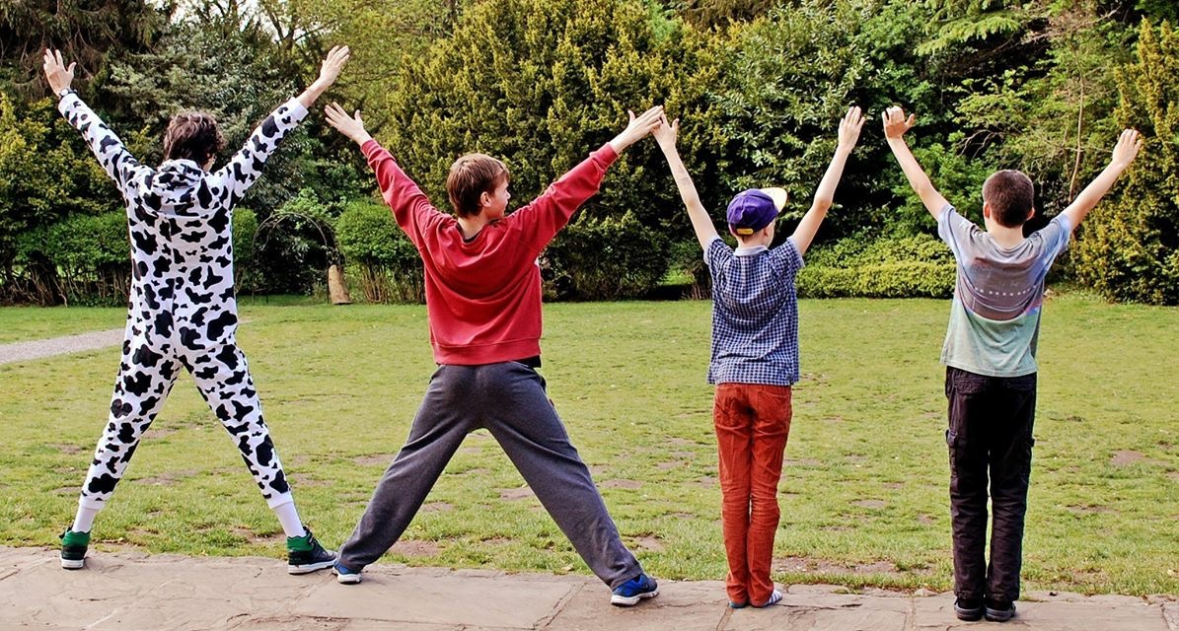
XXYY UK Sponsorship Form
Money raised helps fund days out and family breaks, bringing medical professionals to the UK, running costs of the website and hoodies for the XXYY boys

NAME | ADDRESS | AMOUNT | TICK  (IF PAID)

THANK YOU FOR YOUR CONTRIBUTION!

